Model |  | V1 | 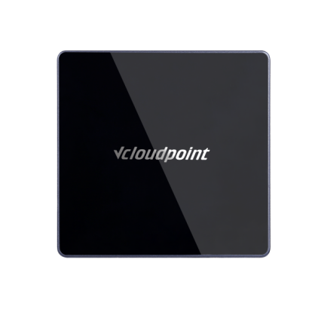  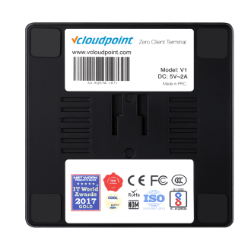  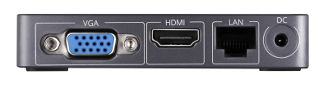  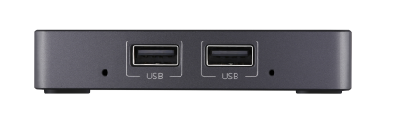  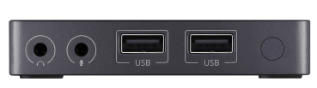
Appearance | Size | 93(W)x90(D)x18(H) mm
 | Weight | 150g
 | Color | Diamond black & moon sliver color
Configuration Methods |  | Host side & Client side
Display Interfaces |  | HDMI / VGA
Networking | Ethernet | 10/100/1000Mbps | Rear Panel
 | WIFI | Optional external WIFI antenna:  802.11b/g/n
I/O | Display | 1×HDMI，1×VGA | Right Panel
 | USB | 4×USB 2.0
 | Network | 1×RJ45
 | Audio | 1×microphone jack, 1×speaker jack | Front Panel
 | Power | 1×5V DC
 | Switch | 1× power/reset switch
Anti-theft Gadget |  | Yes
Power Consumption |  | 5W
Resolution |  | Normal display resolutions (32 bits @ 60Hz):  640×480, 800×600, 1024×768, 1280×1024, and 1600×1200  Wide display resolutions (32 bits @ 60Hz):  1360×768, 1366×768, 1440×900, 1600×900,1680×1050, and 1920×1080
Audio |  | 16 bits, 44.1Khz/ 48Khz audio input / output via 3.5mm stereo jacks
Video |  | Full HD 1080p for all media formats (Host side rendering for local and web-embedded videos on most media players; Client side rendering for local videos on VLC player 2.1.5 or newer versions.)
Supported USB  Peripherals |  | Storage Devices, USB Hubs, Single, Multi-functional & Dot Matrix Printers，Smart Card Reader, Office & POS Scanners, Single Touch Screens, Ukeys, Parallel to USB Convertors, etc; An external power supply may be required for devices working on large voltage. View more USB devices at  http://www.vcloudpoint.com/wp-content/uploads/documentations/ENG/Tested_USB_Devices.xls
Maximum number  of users per shared host |  | vMatrix Server Manager permits up to 99 users per shared host. Actual number of supported users depends on the host configuration and the type of applications used. View Host Configuration Guide at  http://www.vcloudpoint.com/wp-content/uploads/documentations/ENG/Host_Configuration.xls
Internal hardware |  | All solid-state design. No moving parts, no fans, no local user storage.
Data Security |  | No local data storage on device. USB data access controlled by user policy.
Environmental |  | 0 to 40 degrees Celsius 10 to 85% relative humidity (non-condensing) No moving parts permits use in high dust / particulate / vibration environments.
Reliability |  | ＞100,000 h
Certifications |  | FCC Class A&B, CE, CCC, RoHS compliant, BIS, NOM, ISO 9001:2015, ISO 14001:2015
User Software |  | Management Software: vCloudPoint's vMatrix Server Manager with Dynamic Desktop Protocol (DDP); Optional vMatrix Classroom Control at additional cost.
Supported Operating System |  | Microsoft Windows XP SP3 Pro 32bits, 7, 8 ,8.1 & 10 (excluding Starter, Home Basic and Insider editions), Server 2003 32 bits, 2008R2, 2012, 2012R2, 2016, 2019, Multipoint Server 2011, 2012.

